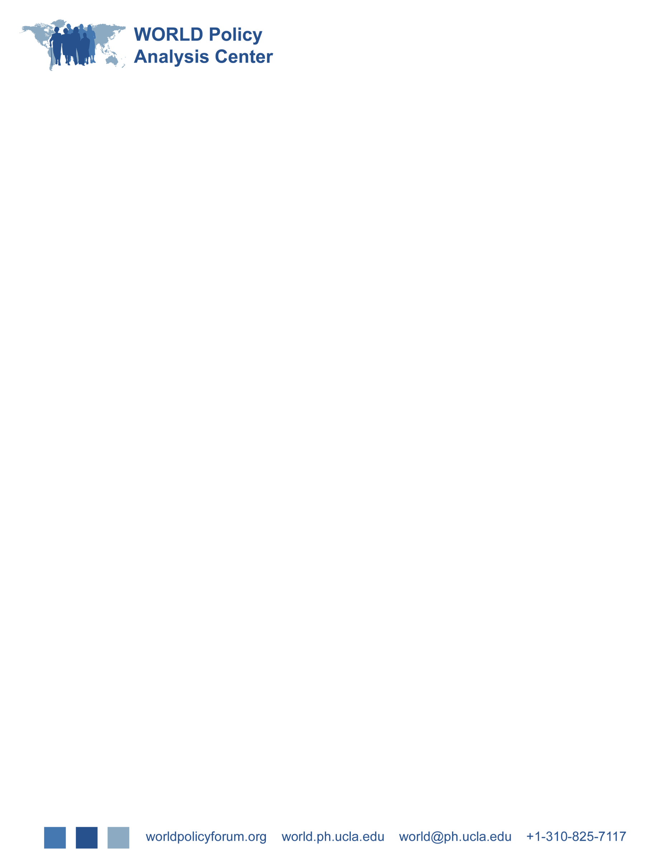

**Paid Sick and Medical Leave**

**Public Use Data Dictionary**



Paid SIck and Medical Leave Public Use Data Dictionary

Contents

About the Data 1

Organizational overview 1

Building the Data Center 1

Data Sources 1

Coding Frameworks 2

Coding Process 3

Accuracy, Analysis, and Updating 3

National and Subnational Levels 4

Adult Labor Database 4

Data 5

Country Identifer Variables 5

Paid Sick And Medical Leave in the Adult Labor Database 6

© 2021 WORLD Policy Analysis Center

All rights reserved.

# About the Data

## Organizational overview

The WORLD Policy Analysis Center has collected and analyzed information on laws and policies relevant to human health, wellbeing, and equality in the following areas: child marriage, education, income, discrimination, work-family, equality, health, disability, child labor, as well as social, economic, civil and political rights.

In creating this dataset, our goal was to ensure the accuracy and timeliness of the data we present. We look forward to receiving feedback from data users if they believe that any individual countries have been placed in the wrong category. If you are aware of an error in our data, please contact us at world@ph.ucla.edu to report the error. Please provide a link to the relevant law from which the information can be verified.

## Building the Data Center

We examine constitutional and legal provisions as they set a foundation for citizens’ rights and are a first step toward improving outcomes. Across countries, having laws on paper does make a difference in practice. Laws and constitutional rights lead to change by shaping public attitudes, encouraging government follow-through with inspections and implementation, and enabling court action for enforcement. Even when local enforcement is inadequate, laws may still have an impact by shaping the terms of political debate and providing levers for civil society advocates. Laws are a mechanism by which power can be democratically redistributed, changes in institutions can be created to ensure greater fairness, and a social floor guaranteeing minimum humane conditions can be established.

When determining the laws, rights, and policies that should be included in the data center, we gave priority to policies that are supported in two ways: with research evidence on their importance to human development, health, or well-being in a variety of geographic, social, and economic circumstances; and with widespread global consensus on their value. If a policy mattered only under a very particular set of circumstances, it was unlikely to make our list.

### Data Sources

In selecting data sources to analyze, we had several priorities. Did the source provide primary data on the question we were looking for? For example, if we were looking for information about minimum age of marriage laws, we would always prefer to read the laws themselves (a primary source) rather than a secondary summary or description of them. Primary sources allowed us to better understand the law or policy and helped us avoid errors that might have been introduced in the secondary sources. Working with primary sources also had the advantage of enabling us to provide links to actual legislation and constitutions for those interested in passing new laws or creating reform in their countries. Documents were reviewed in their original language or in a translation into one of the UN’s official languages.

Although we used primary data whenever possible, we also used secondary sources when information was unclear or lacking on particular countries. In choosing these secondary sources, we gave priority to national reports to the UN and official global and regional bodies and those that were comparable across multiple countries. When we were using information sources that covered a limited number of countries, we aimed to ensure that the information they contained could be made consistent with our other sources.

### Coding Frameworks

Conceptually, frameworks had to be developed that allowed the comparison of laws and policies across all the world’s countries, even when there was a great deal of variation in the approach taken by individual nations. Questions that originally seemed simple to answer across all countries rarely were. For instance, countries do not simply prohibit or allow child labor below a certain age; many permit work below the minimum age in certain industries or under specific conditions. Once children are allowed to work, there is a range of legislation addressing when they can work, for how long, and under what conditions. As another example, we originally thought that the minimum wage could be captured by a few currency figures. However, we found enormous variation in everything from how the minimum wage was set to how it was determined, and whether and when it was increased to who was exempted. Despite this complexity, the minimum wage was straightforward compared to analyzing a question about equal rights in constitutions. What domains should constitutions cover in providing equal rights? Does it matter if they have a general equal-protection clause but do not spell out specific groups? Which named groups should be captured, and how can this be done consistently? As well, citizens are rarely simply denied or granted certain rights; these rights are subject to provisions regarding whether they can be denied under certain circumstances, whether the nation guarantees the right or just aspires to it, whether positive action can be taken for certain populations, and whether citizens are permitted to defend the right in court, among others.

In developing analytic approaches for each policy area, we began with the essential features, based in intrinsic characteristics of the policy or law, research evidence on important features, and global agreement where it existed. For example, in the case of child labor, international agreements and the evidence base distinguish light work from general employment and hazardous work. In the case of equal rights in constitutions, international agreements have forged consensus on the importance of equal rights across a wide range of features, including gender, ethnicity, and disability, among others; they also underscore the importance of equal rights in social and economic, as well as civil and political, areas.

After determining a set of key features, research analysts read laws and policies from 20 to 30 countries to develop closed-ended categories according to which these features could be coded while capturing the full variety of approaches taken by countries. They then tested this coding system on an additional 10 to 20 nations before implementing it for all countries.

Our priority was to ensure that the richness and variety of approaches that different countries took were well captured. At times, research teams would have already analyzed 60 to 80 countries before coming across a single country whose approach to a particular problem was different enough in important ways that it could not be adequately captured within the coding scheme. In these cases, the coding scheme was revised to add the elements necessary to capture new features of legislation and policymaking that had presented themselves. All previously coded nations were reviewed to determine whether the revised coding system would alter how they were analyzed. In other words, the new coding system, better adapted to the full variety of approaches nations around the world take, was applied to all countries in the end.

The data sources available contained systematic information on legislation and policies but not on implementation. To ensure consistent approaches across countries, reports that contained comprehensive information on policies but only limited incidental information on implementation were coded only for policies. Obtaining systematic sources of information on implementation should be a pressing priority for global organizations.

### Coding Process

Coding is the process by which an individual researcher takes a piece of information in legislation, policy, or constitutions and translates it into a set of features that can be mapped, quantitatively analyzed, and readily understood and shared. For example, a researcher would review many pieces of labor legislation and use them to answer such questions as the following: At what age can children or youth engage in hazardous work? How many hours are they permitted to work per day or per week? To capture this information as reliably as possible, coding was carried out whenever feasible by team members fluent in the relevant language of the original documents or in the language into which it had been translated.

Although the coding was designed to be as straightforward as possible to increase reliability, some questions required judgment calls. To make our approach transparent and consistent, the rules for making these judgments were captured systematically in a codebook used by everyone involved in the particular database.

Policies, laws, constitutions, reports, and secondary sources were coded independently twice, and the results of each coding were compared to minimize human error. Where there was disagreement due to human error and the answer was straightforward, the coding was corrected. Where researchers arrived at different conclusions based on judgment, the two researchers discussed the best answer on the basis of coding guidelines and coded their consensus answer. Where they did not agree, a team meeting was called to determine the best way to proceed.

### Accuracy, Analysis, and Updating

Nations that were outliers on particular policies were verified using external sources whenever possible. We recognize that even with all the efforts to provide information that is as accurate as possible, errors are nearly inevitable. The UN and other sources we used may not always have the most up-to-date legislation where primary data were used. Any error or omission in national submissions that we used will also be reflected in our data. Finally, even with the double coding, the research team can make errors. We look forward to receiving feedback from readers if they believe that any individual countries have been placed in the wrong category. We will update country reports in our databases when we receive new primary sources of legislation indicating that changes should be made.

### National and Subnational Levels

The WORLD Policy Analysis Center databases focus largely on the national level. However, in federal systems, states or provinces may legislate a variety of areas. In some cases, omitting subnational legislation is not a significant omission—in China, for example, laws can be passed by provinces as well as the national government, but most legislation is in fact passed nationally. In other countries, like the United States, legislation may be equally passed by the federal government and by states, but historically, once most states have had guarantees, these have typically become federal. However, in other federal contexts, like Canada, federal and provincial jurisdictions are quite distinct. Many social policies are under the jurisdiction only of provinces. In this case, not having subnational information is a greater omission.

Data analysis focused on national-level law and policy collected by the UN and other global organizations. For countries that legislate at the sub-national level and have no federal policy in place, we coded based on the lowest level of protection set at the state or provincial level.

## Adult Labor Database

These indicators on paid sick leave are part of the WORLD Policy Analysis Center (WORLD)’s Adult Labor Database. WORLD created the Adult Labor Database through a systematic review of original, national labor and social security legislation, complemented and verified by information from secondary sources. This data reflects laws in place as of September 1, 2020 and does not reflect temporary policy changes in response to COVID-19. The full-text copies of these laws, in addition to the corresponding information on their history of amendment and repeal, were located mainly through the International Labour Organization (ILO)'s NATLEX database. When full-text labor legislation was not available through NATLEX, researchers located this legislation through official country websites, and in some cases, copies of legislation were obtained from libraries such as the Swiss Institute for Comparative Law, the UCLA Law Library, the Harvard Law Library, and the McGill University library.

To complement legislative review, we consulted the following secondary sources for context and to clarify information:

* The Social Security Programs throughout the World (SSPTW) database, based on data from the International Social Security Association and other supplemental sources. SSPTW reports were reviewed for every country in our database for which they were available.
* Benefit summaries and information available from the Mutual Information System on Social Protection, and the Mutual Information System on Social Protection of the Council of Europe.

# Data

While exhaustive methods were used to collect data, comparable information was not always available for all 193 UN member states for every indicator. In these cases, the relevant variable will be blank in the datasets.

## Country Identifer Variables

| **Variable Name** | **Variable Values** | **Variable Description** |
| --- | --- | --- |
| country |  | Name of country |
| iso_2 |  | 2-digit ISO country code |
| iso_3 |  | 3-digit ISO country code |
| region |  | Country geographical region (World Bank classification)[1] |
| World Bank Country Income Group  (wb_econ) | 1: Low-income  2: Middle-income  4: High-income | Country income group classification  (World Bank: December 2020) |

## Paid Sick And Medical Leave in the Adult Labor Database

| **Variable Name** | **Variable Values** | **Variable Description** |
| --- | --- | --- |
| Are workers guaranteed paid sick leave?  (paid_sicklv) | 1: No sick leave  3: Unpaid sick leave  5: Paid sick leave | * This variable examines whether national legislation guarantees any sick leave—paid or unpaid—to workers. |
| Are workers entitled to paid sick leave from the first day of illness?  (sick_1stday) | 1: No, none  3: No – paid leave, but not from first day  5: Yes, paid from first day | * Paid sick leave from the first day of illness supports workers’ ability to stay home at the first sign of symptoms which is critical to reducing infectious disease spread. * *No – paid leave, but not from first day* means that countries impose unpaid waiting periods before workers are able to claim paid sick leave benefits. For purposes of this variables, countries that waive waiting periods for longer illnesses are still considered to have a waiting period because workers do not necessarily know from the onset of symptoms how long they will be sick. |
| What is the duration of paid sick leave that workers have access to?  (sick_dur_*) | 1: No paid sick leave  2: Less than 2 weeks  4: 2 – 5.9 weeks  5: 6 weeks or more  999: Varies by worker type | This is a series of variables examining the duration of paid sick leave by worker tenure (1 month – 1m, 6 months – 6m, 1 year – 1y, and 5 years – 5y).   * At least two weeks of paid sick leave supports workers’ ability to self-quarantine during the COVID-19 pandemic. Lengthier leave supports complications and other types of illnesses. * Length of leave is calculated based on a five-day workweek unless legislation suggests a six-day work week or calendar days. Length of leave does not include extensions available only in the case of hospitalization. * When it varies, length of leave is calculated based on how long a worker has been working with their employer. Contribution requirements that require a minimum number of contributions while employed within a specific time period prior to being eligible for social security-based leave are also included. * *Varies by worker type* means that length of paid sick leave benefits varies based on how the worker is classified, such as whether the worker is paid hourly, a salaried employee, or a supervisor. |
| What is the wage replacement rate of paid sick leave in week 1?  (sick_wrr_w1_*) | 1: No paid sick leave  2: Flat rate benefit  3: Less than 60% of wages  4: 60 – 79% of wages  5: 80 – 100% of wages  999: Varies by worker type | This is a series of variables examining the wage replace rate of paid sick leave in week 1 by worker tenure (1 month – 1m, 6 months – 6m, 1 year – 1y, and 5 years – 5y).   * Adequate wage replacement rates determine whether workers can afford to take paid leave. * Wage replacement rate is calculated taking into account any unpaid waiting periods, expiration of benefits, or changes in benefit levels. Calculations are based on a five-day workweek unless legislation suggests a six-day work week or calendar days. * When it varies, wage replacement rate is calculated based on how long a worker has been working with their employer. Contribution requirements that require a minimum number of contributions while employed within a specific time period prior to being eligible for social security-based leave are also included. * *Flat rate benefit* means that all workers receive the same payment, regardless of their usual wages or salary. * *Varies by worker type* means that length of paid sick leave benefits varies based on how the worker is classified, such as whether the worker is paid hourly, a salaried employee, or a supervisor. |
| What is the wage replacement rate of paid sick leave in week 2?  (sick_wrr_w2_*) | 1: No paid sick leave  2: Flat rate benefit  3: Less than 60% of wages  4: 60 – 79% of wages  5: 80 – 100% of wages  999: Varies by worker type | This is a series of variables examining the wage replace rate of paid sick leave in week 2 by worker tenure (1 month – 1m, 6 months – 6m, 1 year – 1y, and 5 years – 5y).   * Adequate wage replacement rates determine whether workers can afford to take paid leave. * Wage replacement rate is calculated taking into account any unpaid waiting periods, expiration of benefits, or changes in benefit levels. Calculations are based on a five-day workweek unless legislation suggests a six-day work week or calendar days. * When it varies, wage replacement rate is calculated based on how long a worker has been working with their employer. Contribution requirements that require a minimum number of contributions while employed within a specific time period prior to being eligible for social security-based leave are also included. * *Flat rate benefit* means that all workers receive the same payment, regardless of their usual wages or salary. * *Varies by worker type* means that length of paid sick leave benefits varies based on how the worker is classified, such as whether the worker is paid hourly, a salaried employee, or a supervisor. |
| What is the wage replacement rate of paid sick leave in week 6?  (sick_wrr_w6_*) | 1: No paid sick leave  2: Flat rate benefit  3: Less than 60% of wages  4: 60 – 79% of wages  5: 80 – 100% of wages  999: Varies by worker type | This is a series of variables examining the wage replace rate of paid sick leave in week 6 by worker tenure (1 month – 1m, 6 months – 6m, 1 year – 1y, and 5 years – 5y).   * Adequate wage replacement rates determine whether workers can afford to take paid leave. * Wage replacement rate is calculated taking into account any unpaid waiting periods, expiration of benefits, or changes in benefit levels. Calculations are based on a five-day workweek unless legislation suggests a six-day work week or calendar days. * When it varies, wage replacement rate is calculated based on how long a worker has been working with their employer. Contribution requirements that require a minimum number of contributions while employed within a specific time period prior to being eligible for social security-based leave are also included. * *Flat rate benefit* means that all workers receive the same payment, regardless of their usual wages or salary. * *Varies by worker type* means that length of paid sick leave benefits varies based on how the worker is classified, such as whether the worker is paid hourly, a salaried employee, or a supervisor. |
| Who provides paid sick leave during the first six weeks of illness?  (sick_provide) | 1: No paid sick leave  3: Employer only  4: Social security only  5: Employer and social security | * Provision of paid sick leave in full or in part by social security during the first six weeks of illness can help reduce the burden on businesses when workers are sick. * *Employers only* means that employers are generally responsible for providing paid sick leave benefits during the first six weeks of illness. Social security programs may provide benefits for longer illnesses or for a subset of workers, such as the self-employed. * *Employer and social security* includes three different ways that employers and social security systems share the provision of paid sick leave benefits. They are: (1) employers pay for a portion of leave before benefits from social security begin, (2) employers are required to supplement benefit levels paid by social security, and/or (3) employers are required to pay benefits when workers do not meet contribution requirements to access paid leave benefits in the social security system. |
| Are workers required to have worked for their employers for a year to receive paid sick leave benefits?  (sick_tenure) | 1: No national paid sick leave  2: Yes, 12 months tenure required  3: At least 12 months of contributions required  4: Tenure or contribution requirements, but less than 12 months  5: No explicit tenure or contribution requirements to access at least some leave | * Tenure or contribution requirements impact whether workers who have recently changed jobs (voluntarily, due to unemployment, or after finishing school), have access to paid sick leave benefits. * *Tenure* refers to length of continuous employment with the same employer * *Contribution* refers to payments (typically a defined percentage of earnings deducted from worker paychecks) made to the national social insurance system * *Yes, 12 months tenure required* means that workers must have 12 months of continuous employment with the same employer to be eligible for paid sick leave benefits * *At least 12 months of contributions required* means that workers must make at least 12 months of contributions to national social security systems to be eligible for paid sick leave benefits. This indicator captures countries which require 12 consecutive months of contributions, as well as countries which require 12 months of contributions over a longer, non-consecutive period (e.g. 12 months of contributions over the past 18 months) * *Tenure or contribution requirements, but less than 12 months* means that workers must be continuously employed or make contributions to social security systems for a minimum amount of time to be eligible for paid sick leave benefits– but this minimum length is less than 12 months * *No explicit tenure or contribution requirements to access at least some leave* means that countries extend workers access to at least some paid sick leave benefits without explicitly requiring a minimum period of employment or number of contributions to a social security fund |
| Do countries guarantee self-employed workers access to paid sick leave?  (sick_self) | 1: No national paid sick leave guaranteed for any workers  3: National paid sick leave, but not for self-employed  5: Self-employed guaranteed national paid sick leave  999: Not specified in law | * Globally, nearly half of all workers are self-employed, and include among their ranks some of the most vulnerable workers—such as street venders. This variable captures guarantees (and denials) to “self-employed,” “own-account,” and “independent workers,” regardless of their sector. * *National paid sick leave, but not for self-employed workers* means that social security benefits explicitly exclude self-employed workers or national benefits are only available through employers. * *Self-employed workers guaranteed national paid sick leave* means that social security legislation explicitly outlines coverage for self-employed workers either as part of the main social security sickness benefit or a separate program. This includes both mandatory and voluntary coverage. * *Not specified in law* means that social security legislation does not explicitly address whether self-employed workers are covered or not. This does not mean that legislation denies coverage to self-employed workers. |
| Do countries guarantee part-time workers access to paid sick leave?  (sick_partalt) | 1: No national paid sick leave  2: Guaranteed to part-time workers who work at least 20 hours per week  3: Guaranteed to part-time workers who work fewer than 20 hours per week  4: Guaranteed to workers generally, no exclusions based on part-time work  5: Guaranteed to part-time workers without an explicit minimum hourly requirement | * *Part-time workers* are employees whose normal hours of work are less than full-time. The International Labor Organization asserts that part-time work has “grown in importance” over past decades—particularly for women for whom it is currently “the most widespread type of non-standard employment.” * Eligibility for paid sick leave benefits is assessed using the definition of part-time work in relation to weekly hours of full-time work as defined in national labor legislation, regardless of sector. For example, if part-time work is defined as 50% of full-time work in a country with a 40-hour work week, it is calculated as 20 hours per week, on average. This threshold is defined in relation to normal full-time hours, and does not include overtime. * *Guaranteed to workers generally, no exclusions based on part-time work* means that workers are guaranteed national paid sick leave, and legislation does not explicitly guarantee nor deny coverage to part-time workers * *Guaranteed to part-time workers without an explicit minimum hourly requirement* means that countries explicitly include part-time workers and (1) there is no explicit definition or threshold for part-time work, or (2) part-time work is defined as a maximum number of hours, or (3) part-time work is defined as “less than full-time.” |
| Do countries with national paid sick leave include eligibility exemptions based on firm size?  (sick_firm) | 1: No national paid sick leave  2: Exemptions for agricultural workers in farms with fewer than 10 workers  3: Exemptions for family or agricultural workers in enterprises with fewer than 6 workers  5: No firm size exemptions to national paid sick leave | * *Exemptions for agricultural workers in farms with fewer than 10 workers* means that while national paid sick leave is broadly available, legislation excludes agricultural workers employed at farms with fewer than 10 workers from eligibility * *Exemptions for family or agricultural workers in farms with fewer than 6 workers* means that while national paid sick leave is broadly available, legislative loopholes exclude family workers or agricultural workers who are employed at enterprises with fewer than 6 employees from eligibility * *No firm size exemptions to national paid sick leave* means that legislation guarantees workers paid sick leave, without any legislative loopholes that exclude workers at smaller enterprises broadly, or in specific sectors |
| Is short-term paid sick leave available that supports reducing infectious disease spread?  (sick_avail) | 1: No paid sick leave  3: Limited paid sick leave  5: At least 2 weeks of well-paid sick leave available from the first day | * This ranking shows the extent to which countries make paid sick leave available from the first day of illness, at a high enough payment that workers can afford to take paid leave, and for at least two weeks. * This map captures guarantees of paid sick leave for workers with one year of tenure. Eligibility requirements that mandate at least a year of contributions while employed within a specific time period prior to being eligible for social security-based leave are also included. * *Limited paid sick leave* means that there is a national paid sick leave policy, but that there is either a waiting period to receive benefits, leave is paid at a flat rate or less than 80% of wages in the second week, or a worker with one year of tenure would receive less than two weeks of paid leave. * *At least 2 weeks of well-paid sick leave available from the first day* means that workers are guaranteed at least 2 weeks of sick leave paid at 80% or more of wages from the first day of illness. |
| For how long are workers guaranteed paid sick leave?  (sickleave_duration) | 1: No paid sick leave  2: Less than 1 month  3: 1 - 2.9 months  4: 3 months – 5.9 months  5: 6 months or more | * This indicator captures the total length of available paid leave for personal health needs through employers and the social security system. * If the duration of sick leave varies, the duration of the sick leave benefit shown is the one that is available to the lowest wage worker with at least one year of tenure. * The benefit duration includes extensions due to hospitalizations, serious illnesses, or chronic illnesses. * *26 weeks or more* of paid leave includes cases where benefits are provided “until recovery” or “for as long as treatment is required.” |

1. Malta is assigned to Europe and Central Asia to be consistent with other international classifications and also with Malta’s own EU-member status.